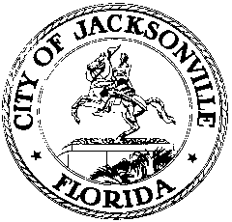

OFFICE OF THE CITY COUNCIL

117 WEST DUVAL STREET, SUITE 425
4TH FLOOR, CITY HALL
JACKSONVILLE, FLORIDA 32202
904-630-1377

CIVIL RIGHTS HISTORY INVENTORY MEETING MINUTES
Conference Room A, Suite 425, 4th floor, City Hall
June 5, 2018
11:30 a.m.

Location: Suite 425, Conference Room A, City Hall – St. James Building, 117 West Duval Street

In attendance: Dr. Tim Gilmore (Co-Chair), Dr. Brenda Simmons-Hutchins

Also: Yvonne P. Mitchell – Council Research Division

See sign-in sheet for additional attendees.

Meeting Convened: 11:44 a.m.

Dr. Tim Gilmore convened the meeting and the attendees introduced themselves for the record. The committee continued its thorough review of Dr. Tim Gilmore’s May 21st proposed revisions up to the 1930’s. The committee will continue to research all information and modify the timeline with combined details and references. The next meeting is Tuesday, June 12th from 11:30 a.m. to 3:00 p.m. A notice will be posted regarding the extended time of the meeting. The committee will present the final draft to the Task Force for review on June 13th. The timeline will be voted on at the special notice meeting on June 20th. The deadline for the final report to Council President Brosche is Monday, June 25th.

There being no further business, Dr. Gilmore adjourned the meeting.

Meeting adjourned: 1:25 p.m.

Minutes: Yvonne P. Mitchell, Council Research
06.05.18 Posted 2:30 p.m.

Tapes: Civil Rights History Inventory Subcommittee Meeting – LSD
06.5.18

Handouts: Civil Rights History Inventory Subcommittee Meeting – LSD
06.05.18

